Homework 5: Hydrogen Orbitals
Brian Burns
PHYS 4350 Computational Physics
Dr. Mayes
May 2004

Goal

Find the eigenenergy and eigenfunctions for the first excited state of Hydrogen.

Schroedinger Equation

The Schroedinger equation for Hydrogen boils down to

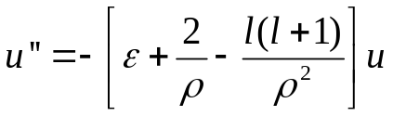

which can be solved numerically for u(ρ), where u = R * r, and Psi(r, angles) = R(r) * Y(angles). Epsilon is the dimensionless energy, and L is the angular momentum quantum number.

Note: This notation differs from the original assignment – this follows the notation in both Griffiths [1] and Liboff [2].

The calculation of u'' at ρ=0 is indeterminate, and will also be inaccurate for small values of ρ, since u will also be small (since u=0 at ρ=0), and the calculation includes u/ρ and u/ρ². To get around this problem and increase the precision, we can use an approximation for u at small ρ, provided by Liboff [2]: u=ρ^{(L+1)}. Plugging this into the Schroedinger equation we obtain the following for the different values of L:

L | u at ρ=0 | u' at ρ=0 | u'' | u'' at ρ =0
0 | 0 | 1 | -ε*ρ - 2 | -2
1 | 0 | 0 | -2*ρ + 2 | 2
2 | 0 | 0 | 6*ρ | 0

For L=2, note that u, u', and u'' are all zero at ρ=0. The eigenfunction can "get off the ground" though, because u'''(0) = 6, although this is not incorporated in the program. By plugging in a a value of 1 for u'' at ρ=0 though, the eigenfunction can be launched away from zero, and the solution obtained matches the analytical solution. Hence this technique can provide the correct eigenfunction for L=2 when starting from ρ=0.

Eigenenergy

The eigenenergy for the first excited state is found by integrating the Schroedinger equation between two boundaries and finding the value of some parameter (in this case the eigenenergy) such that the boundary conditions are satisfied. We use a shooting technique – starting at one boundary we integrate the Schroedinger equation for some value of the energy and see if we reach the other boundary correctly. We iterate this process until we reach the correct boundary conditions within some limit, and the value of the energy for this curve is the eigenenergy, the curve itself being the eigenfunction.

Since there are multiple eigenenergies for the Hydrogen atom, we must limit the search to some range, or else find all the eigenenergies starting with the ground state and count upwards until we reach the one we are searching for. For this assignment we were told to search between energy values of -1/8 and -1/2, since we know that the eigenenergy for the first excited state is at -1/4.

The two boundary conditions that we know for the eigenfunction are at ρ=0 and at ρ=infinity. Since we can't actually integrate to infinity, we integrate to some large values of ρ (call them ρ₀), and try to extrapolate to see what would happen if we were to actually integrate to infinity. This will give us our final value for the eigenenergy.

The values obtained for the eigenenergy ε at five different values for ρ₀, using nsteps=10⁷, and extrapolated to ρ₀ = infinity, are as follows:

ρ₀ | 1/ρ₀ | eigenenergy ε
20 | 5.00000000000000E-02 | 2.49996899417367E-01
30 | 3.33333333333333E-02 | 2.49999999472674E-01
40 | 2.50000000000000E-02 | 2.49999999999939E-01
70 | 1.42857142857143E-02 | 2.50000000000002E-01
100 | 1.00000000000000E-02 | 2.50000000000002E-01
infinity (extrapolated) | 0.00000000000000E+00 | 2.49999381408503E-01

A plot of these values follows:

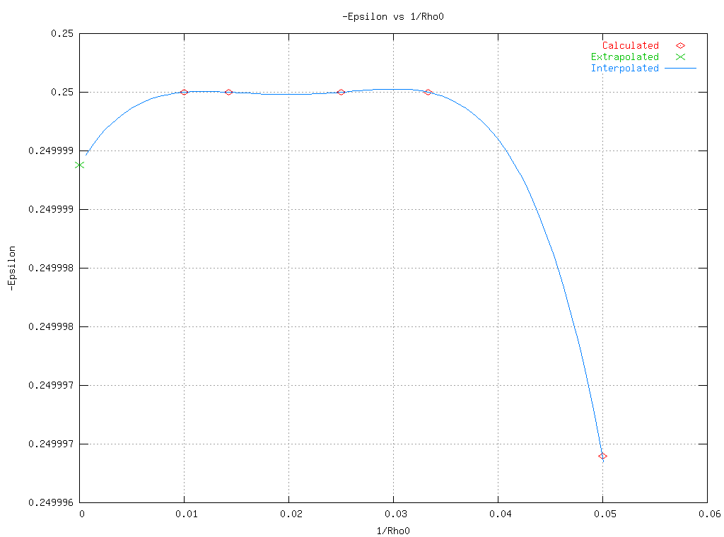

Note that using the Lagrangian polynomial interpolation does not work well for finding the eigenenergy - the extrapolated line does not converge towards the correct answer of -0.25. This is due to the way that polynomial interpolation works - it has a tendency to oscillate for more than a few data points.

Analyzing the Error

Going back to previous table, note that the energy seems to approach the correct answer of -0.25 and then starts receding from it. To find out what was going on, data was obtained for more points to see what the dependence of the error was on ρ₀. The following log-log chart shows a plot of the error in epsilon versus ρ₀, for nsteps=10⁵.

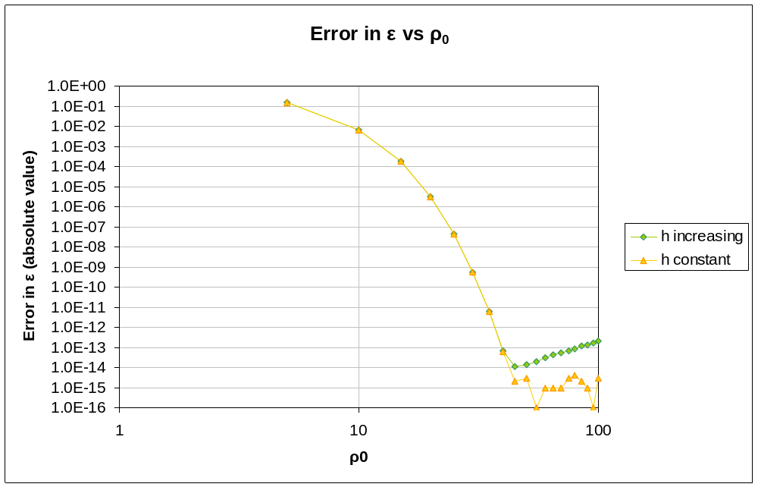

The green diamonds show the behavior when the step size h is allowed to increase as ρ₀ increases (the default behavior, since nsteps was left constant at 10⁵).

The orange triangles show the behavior when the step size h is fixed at 5e-5, corresponding to ρ₀=5 and nsteps=10⁵.

For the green line, the dependence becomes linear past a certain point, indicating that the error is due to the increasing step size. For example, if the error was

error = a h^{m}

where a and m are some constants, then ln(error) = m ln(a h). In this case, h is proportional to ρ₀, since h = ρ₀ / nsteps, so ln(error) = m ln(a ρ₀/nsteps), or

ln(error) = b + m ln(ρ₀)

where b is some other constant. Using the endpoints of (45, 1.099e-14) and (100, 2.03e-13) we obtain the natural log of the endpoints (3.8066, -32.1418) and (4.6052, -29.1007), which gives a slope of m = (-29.1007+32.1418) / (4.6052-3.8066) = 3.0411 / 0.7986 = 3.8. So the error in the linear section of the green line is approximately proportional to h⁴, which is what you would expect from the 4th order Runge-Kutta routine.

The orange line seems to oscillate about the limits of precision for double precision numbers (1e-15), so it appears that going out past ρ₀=45 doesn't provide any additional accuracy, even using only 10⁵ steps.

Runge-Kutta and Simpson's Rule

The assignment said to use our previously written Runge-Kutta routine to perform the discrete integral of the area under the eigenfunction, but the Runge-Kutta routine for a function of one variable just becomes Simpson's 1/3 Rule, at least for the constants most frequently used for Runge-Kutta. As derived in class though, our Runge-Kutta routine would give a different weight to the points than Simpson's rule:

For Runge-Kutta,

y = y + h/6 * (f₁ + 2f₂ + 2f₃ + f₄)

If f(x,y)=f(x), as we have for our calculated eigenfunction, the points as derived in class would be:

f₁=f(x), f₂=f(x+h/2), f₃=f(x+h), f₄=f(x+h)

whereas Runge-Kutta routines more frequently use (see, for instance, [3])

f₁=f(x), f₂=f(x+h/2), f₃=f(x+h/2), f₄=f(x+h)

the latter simply gives Simpson's 1/3 Rule:

y = y + h/6 * (f(x) + 4*f(x+h/2) + f(x+h))

whereas the former gives

y = y + h/6 * (f(x) + 2*f(x+h/2) + 3*f(x+h))

Since this doesn't appear to be a standard weighting, I chose to use Simpson's rule for performing the discrete integral (see the routine IntegrateDiscrete).

Eigenfunction

The radial eigenfunction for the first excited state (n=1, L=0) is plotted below in red. Note the correspondence with the exact solution. The radial probability density is plotted in green, and the helper function u used to solve Schroedinger's equation is plotted in gray.

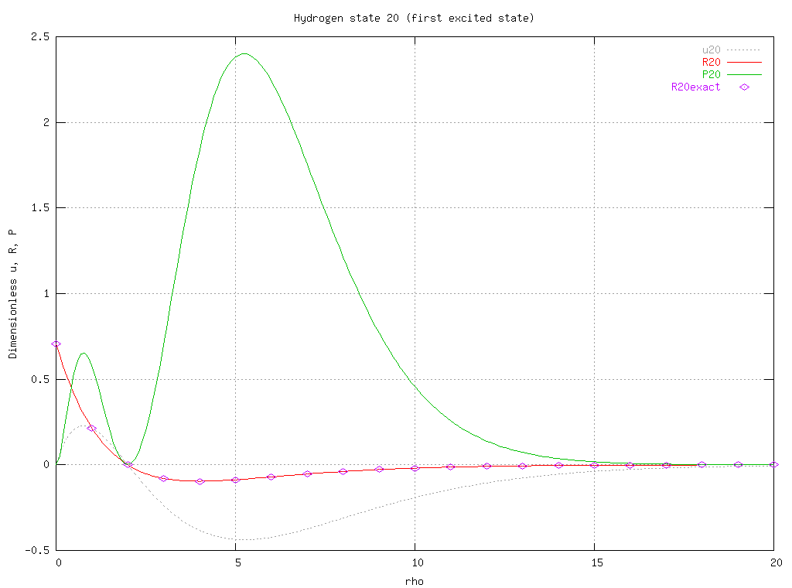

Eigenfunctions for the first six states of Hydrogen were obtained (ie n=0 through n=2), but are not shown here.

Conclusion

It's important to be careful in using a polynomial extrapolation/interpolation routine, since it can lead to oscillations that will give invalid results, even with smooth data sets. And if the data values are already close to the machine precision, doing an extrapolation is liable to only give a less accurate value, so if the values have stabilized with differences on the order of 1e-15 (for double precision), there's no need to do an extrapolation.

References

[1] David J. Griffiths, Introduction to Quantum Mechanics, 1995, p. 141

[2] Richard L. Liboff, Introductory Quantum Mechanics, 4e, 2003, p. 447, 456

[3] Eric W. Weisstein. "Runge-Kutta Method." From MathWorld--A Wolfram Web Resource. http://mathworld.wolfram.com/Runge-KuttaMethod.html

